## TEXT DETECTION AND EXTRACTION FROM VIDEO USING DEEPLEARNING TECHNIQUES

A THESIS SUBMITTED TO

DEFENCE INSTITUTE OF ADVANCED TECHNOLOGY , PUNE FOR THE SEMESTER THREE EVALUATION (2021-2023) OF MASTER OF TECHNOLOGY

IN

DATA SCIENCE

BY

### RAMKRISHANA MARRI

(Roll No. 21-27-21 )

UNDER THE SUPERVISION OF

### Dr.Odelu Ojjela



#### SCHOOL OF COMPUTER ENGINEERING

**& MATHEMATICAL SCIENCES**

### DEFENCE INSTITUTE OF ADVANCED TECHNOLOGY (DEEMED UNIVERSITY),

**PUNE, INDIA DEC 2022**

# Dedicated to

#### I would like to dedicate this thesis work to my family members, Teachers and each and everyone who supported and motivated me

**C E R T I F I C A T E**

This is to certify that the Thesis entitled “**Text Detection and Extraction from Video using Deep Learning Techniques** ” submitted to Defence Institute of Advanced Technology, Girinagar, for the award of the degree of ***Master of Technology***, is the bonafide research work done by **Mr. RAMKRISHANA MARRI** under my supervi- sion. The contents of this thesis have not been submitted elsewhere for the award of any degree.

Dr Odelu Ojjela Asso.Professor

Defence Institute of Advanced Technology

. Girinagar, INDIA

#### DECLARATION

This is to certify that the work presented in the Thesis entitled **“Text Detection and Extraction from Video using Deep Learning Techniques”**, is a bonafide work done by me under the supervision of **Dr Odelu Ojjela** and has not been submitted elsewhere for the award of any degree.

Date:

Place:

Name : RAMKRISHANA MARRI Roll No. : 21-27-21

Department : So CE & MS

Defence Institute of Advanced Technology Girinagar, Pune

#### COUNTERSIGNED

INTERNAL SUPERVISOR

Dr Odelu Ojjela Asso.Professor DIAT PUNE

EXTERNAL SUPERVISOR

Dr J V SatyaNarayna Scientist G

RCI DRDO

#### ACKNOWLEDGEMENTS

I would like to convey my heartfelt gratitude to Dr. J V SatyaNarayana. His efforts to help me with my thesis have been the only thing that has kept me motivated and on task. He’s continuously challenged me to think critically and pick up new information. At the same time, he has also been a calming influence when there have been setbacks in the research work. I would like to thank Dr.Odelu Ojjela for his tremendous support and guidance to define the problem statement and for mentoring me to learn and work on the project for M.Tech in Data Science.

I would also like to express my gratitude to my colleagues for their valuable discussion on the topics.

#### A B S T R A C T

With advanced technology, smart devices and high- speed internet Textual content ap- pearing in semantic retrieval of videos, live stream videos, as well as YouTube videos. The current research offers a thorough framework for finding and identifying text in video frames. Videos have shown to be a fantastic source of knowledge. There is a tonne of information and data in the video’s text, but it could not be changed. If this content could be edited, that would be helpful information for us. The primary task at hand right now is to extract the text from the video. Deep learning techniques are the foundation for text recognition from video frames. Convolutional neural networks (CNN) and long short-term memory (LSTM) networks were combined for deep learning. People should provide as input the video he/she wants to capture the text. The technology analyses the video and produces the text in a text file that may be edited.

**Keywords— OCR, Frames, text detection, Text Recognition, LSTM, CNN.**

# Contents

|  |  |
| --- | --- |
| **Dedication** | **i** |
| **Certificate** | **ii** |
| **Declaration** | **iii** |
| **Acknowledgements** | **iv** |
| **Abstract** | **v** |
| **1 Introduction and Literature Review** | **1** |
| 1.1 Introduction . . . . . . . . . . . . . . . . . . . . . . . . . . . . . . . . . . . . | 2 |
| 1.2 Literature Review . . . . . . . . . . . . . . . . . . . . . . . . . . . . . . . . . | 3 |
| **2 Problem Statement And System Overview** | **4** |
| 2.1 Problem Statement . . . . . . . . . . . . . . . . . . . . . . . . . . . . . . . . | 4 |
| 2.1.1 Natural Text: . . . . . . . . . . . . . . . . . . . . . . . . . . . . . . . | 4 |
| 2.1.2 Superimposed text: . . . . . . . . . . . . . . . . . . . . . . . . . . . . | 5 |
| 2.2 System Overview . . . . . . . . . . . . . . . . . . . . . . . . . . . . . . . . . | 6 |
| 2.2.1 Frame Generation: . . . . . . . . . . . . . . . . . . . . . . . . . . . . | 6 |
| 2.2.2 Text Recognition and Extraction: . . . . . . . . . . . . . . . . . . . . | 7 |
| 2.2.3 Text File Generation: . . . . . . . . . . . . . . . . . . . . . . . . . . . | 7 |
| **3 Methodology** | **8** |

vi

CONTENTS vii

3.1 workflow . . . . . . . . . . . . . . . . . . . . . . . . . . . . . . . . . . . . . . 9

3.2 Text detection : . . . . . . . . . . . . . . . . . . . . . . . . . . . . . . . . . 9

* 1. Determining Bounding Boxes : 10
  2. Text Extraction : 10

1. Description of Deep Learning Model Used 12
   1. Optical Character Recognition (OCR) 12
   2. Google Tesseract 13
   3. Tesseract-OCR 13
   4. Convolutional Neural Network (CNN) 14
   5. Long short-term memory (LSTM) 15
2. Results-and Conclusions 18
   1. Results 18
   2. Conclusion 22

References 23

# Chapter 1

**Introduction and Literature Review**

1

## Introduction

With advanced technology and increasing internet speed, interest of people shifting from TV to Youtube. The biggest benefit of Youtube over TV is that it provides individuals with the necessary videos. People have a limited amount of time because TV is fixed according to their schedule. As the focus shifts to Youtube, the technology now being developed enables individuals to efficiently and quickly access the information present in the text of these films. The current approach transforms the video’s content into changeable form, which is then saved in a text file.Videos related to news, science, health, politics, and education are frequently found on Youtube. Videos have shown to be a fantastic source of knowledge. There is a tonne of information and data in the video’s text, but it could not be changed. This text will be helpful information for us, it will be kept effectively, and it will be simpler to access it in the future if it is changed to editable form. After seeing an educational film once, a person could decide not to view it again because he has already seen it in its entirety and has read the key points, which have already covered the subject. At that point, the suggested solution facilitates information access for the public by transforming the video’s text into an editable form. text files that are editable The key benefit of the text file is that it takes less time to read than a movie. Additionally, if users wish to add any extra information that is impossible to include in a video but is possible in a text file, they can edit the content in the text according to their needs.

The proposed system’s operation is simple and user-friendly. if someone gets a video from a website, such as Youtube, from which they want to extract the text. The proposed system take video as input and divides the movie into individual frames and performs text extraction and detection on each frame. Each frame’s identified text is saved in a text file.

#### Highlights

* The given video input is converted into video frames
* Different filters are applied on each frame before text extraction
* Tesseract-OCR was used to extract texts from each video frame

#### Requirements:

* OpenCV
* Python
* Tesseract-OCR

## Literature Review

Tarek Zlitni,Baseem Bouazziz, Waliid Mahdi [2] automated video text extraction explained It does video indexing based on content. This approach can only find static text that has been overlaid.

Datong Chen, Jean-Marc Odobez [3]have put forth a technique that reduces charac- ter mistake rates and eliminates character noise, both of which significantly impair optical character recognition.

Lifang Gu [5] text detection in MPEG (Mooving Picture Expert Groups) video frame was discussed. Redundancies in spatial and temporal data are decreased. Only MPEG videos can be converted using this method.

Anubhav Kumar, Neeta Awasthi [6], have suggested a technique to localise the text information in both image and video formats. It’s easy to identify and extract text from photos, but more challenging to do so when a video is playing. It’s easy to extract the text files from the multimedia file once the machine finds them. This system’s disadvantage is that processing lengthy videos takes a very long period.

PunitKumar, PS.Putttaswamy [7] have suggested a solution that applies region filtering to get rid of noisy blobs in the image. When the background exhibits sharper changes in intensity, this strategy is ineffective.

# Chapter 2

**Problem Statement And System Overview**

## Problem Statement

There are two types of text occurring in a video

* + - Natural text
    - Superimposed text

### Natural Text:

NaturalText is the text that appears in the video while it’s being recorded. These texts are part of a video recorded scene [2]

Example: Flat Number, Vehicle Number Plate, Name plate, etc.

4

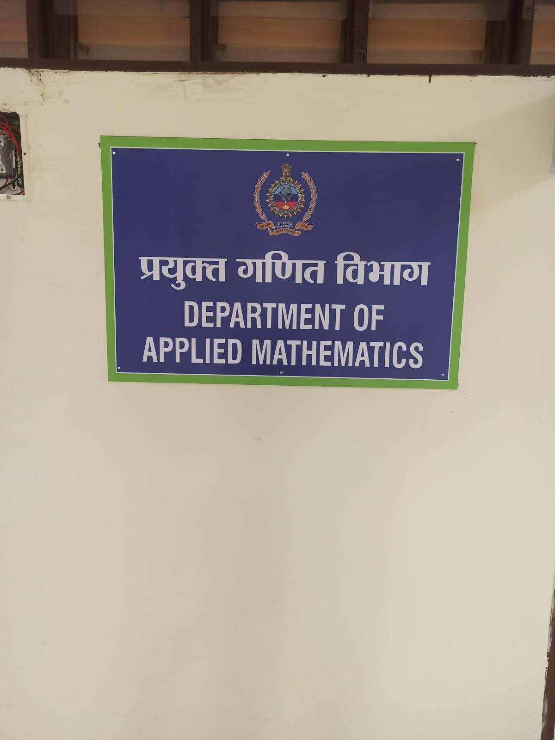

Figure 2.1: Figure Natural Text

### Superimposed text:

Superimposed Text: SuperimposedText is text that is added to video after it has been shot but before it was actually part of the scene.

Ex: Text that appears in a news video. [2]

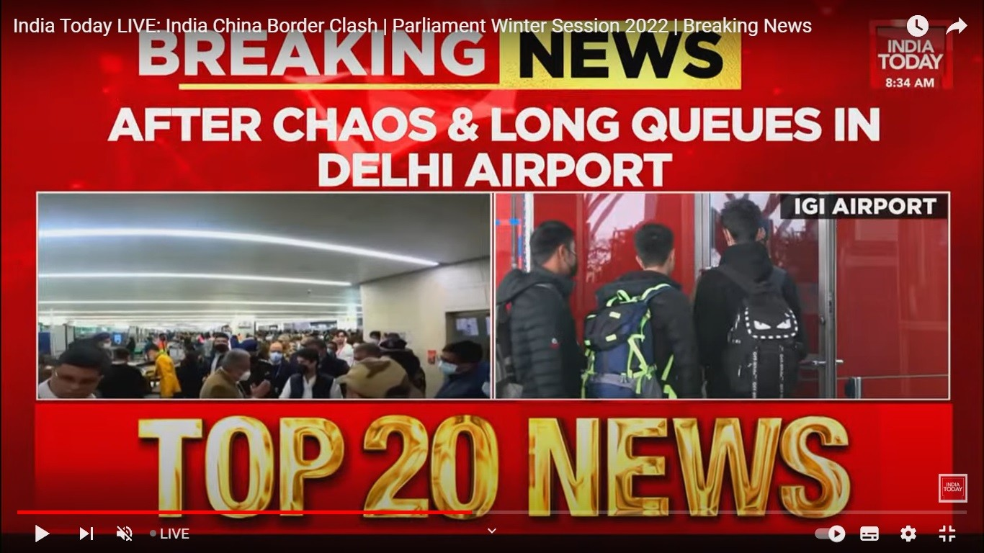

Figure 2.2:

## System Overview

The proposed system has 3 main components:

* + - FrameGeneration
    - TextRecognition and Extraction
    - TextFile Generation

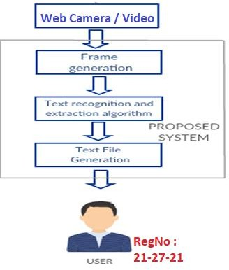

Figure 2.3: System Overview [1]

### Frame Generation:

The video is turned into frames in this stage. Images from a certain point in a video are called frames. The frames are generated at regular intervals so that text in the following frame doesn’t repeat itself a lot. Any picture format can be used to save these frames. When converting video to frames, the users will have two choices. The first is to convert the whole video, and the second is to convert a particular section of the video. People will choose

option one if they want text from the entire video. People will choose the second option, which allows them to choose the start time and finish time for text extraction, if they just require text from a specific time period. The chosen video clip will be converted into photos and kept in a differnt folder for easy to access while a text-extraction technique is applied to it.

### Text Recognition and Extraction:

This process is carried out for each frame. Using Tesseract-OCR explained in the following section, the text region is found in this phase. To improve the effectiveness of text extraction, the discovered text sections are then refined. On the regions that have been identified, the text extraction method is applied. Font colour, text size, backdrop colour, and video resolution all have an impact on how well text is detected. [3].

### Text File Generation:

A text file is used to hold the retrieved text. The created text is added to the preceding text in the text file and saved for each frame. People will be provided the path to the result file after all of the photos’ text has been extracted. The text file is considerably smaller in size than the movie. As a result, information may be accessed more quickly and memory is conserved.

# Chapter 3 Methodology

The suggested framework is described in detail in this section and is illustrated in Fig.

3.1 The text detector, script identifier, and text recognizer are the three key components that make up the entire system. A wide range of systems, such as content summarization, key-word-based alert generation, and indexing and retrieval, can be built on top of these modules at the application layer. The first module, text detector, is required to locate and recognise every piece of text in a frame. Since text can appear in many scripts (within the same frame), the text portions that have been found are provided to the script identification module, which splits the text lines according to the script (English as well as other Indian Language being the two-scripts considered in the current study). The text is then forwarded to the respective recognzation engines of each script, where they convert the images of the text lines into words that can be used to a range of situations.

8

## workflow

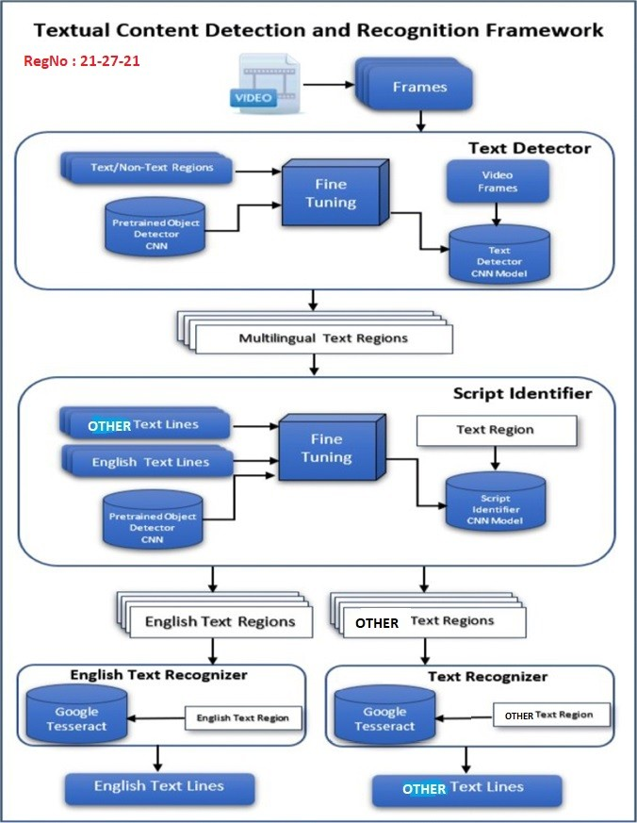

Figure 3.1: workflow [9]

## Text detection :

The proposed framework’s first step is the identification of potential text sections in the retrieved video frames. Modern object detectors based on convolutional neural networks

(CNN) have been used to recognise textual information in a given frame. Despite the fact that many object detectors are highly accurate in detecting and recognising various objects and have been trained on tens of thousands of class examples, they cannot be used to directly recognise text regions in photos. These models must be adjusted for the particular issue of separating text from non-text regions. These models’ convolutional bases can be trained entirely from scratch or pre-trained models can be improved by giving them practise on regions with and without text.

## Determining Bounding Boxes :

The individual characters will initially be combined into a single connected component before the bounding box of the text region is computed. To eliminate any outliers, this can be done by morphologically closing and then opening.

## Text Extraction :

The Tesseract OCR package, which comprises of an optical character recognition (OCR) engine icalled ilibtesseract iand ia icommand-line itool icalled iTesseract, iis iused ifor itext iextrac- ition. iThe iLong iShort-Term iMemory i(LSTM) ibased iOCR iengine, iwhich iconcentrates ion iline iidentification iand ialso irecognises iletter ipatterns, iis inow ia ipart iof iTesseract. iRecurrent ineural inetworks iare ibuilt ion ithe iLSTM inetwork ias itheir icore. iThe iPython-Tesseract ioptical icharacter irecognition i(OCR) itool iis iused ito iextract itext. iThis iprogramme ican i”read” iand irecognize itext ithat iis icontained iwithin ipictures.

All image types, including bmp, JPEG, PNG, GIF, and others, are read by this programme. It is a wrapper for Google’s Tesseract- OCR Engine. The Python Imaging Library is capable of displaying these images. Once the text information has been retrieved from the image files we can utilise it. [3]

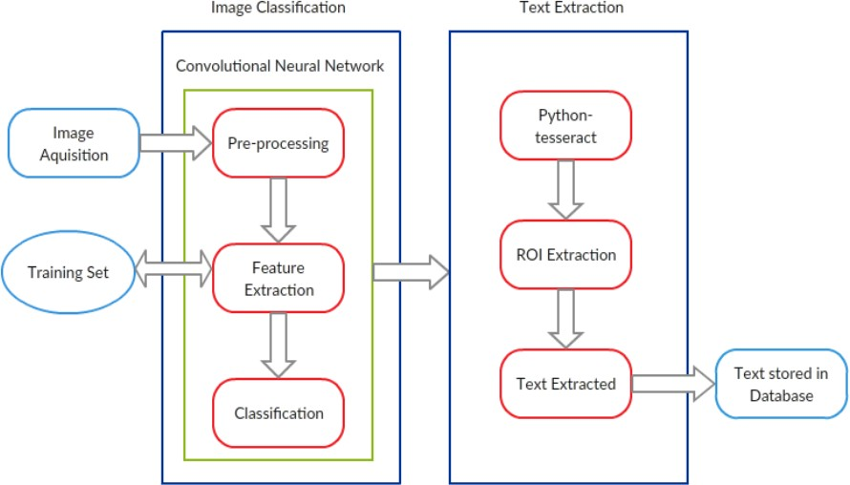

Figure 3.2: [4]

# Chapter 4

**Description of Deep Learning Model Used**

## Optical Character Recognition (OCR)

OCR systems transform a two-dimensional image or frame of text that could contain text from its image or frame gives into computer-readable text. OCR as a process consists of several sub-processes to perform as perfectly as possible.

The sub processes are: Preprocessing of Image Localization of the text Character Recognition Post Process

12

## Google Tesseract

The most modern OCR engine,The Google Tesseract provides excellent accuracy in a wide range iof ilanguages, iincluding iEnglish. iIn iour isystem, iwe iemployed iTesseract iversion i5.2.0, ia irecent irelease ifrom iGoogle. iVersion i5.2.0 is ibuilt iusing ideep ineural inetworks, imore iespecially irecurrent ineural inetworks iwith iextended short-term imemory architecture. iThe iEnglish itext lines are entered into the recognition engine, which then outputs the pertinent textual strings.

In HP Labs, Bristol, Tesseract was first developed as a Ph.D. research project. Between 1984 and 1994, HP created it and it became well-known. Tesseract was made available as open-source software by HP in 2005. It has been created by Google since 2006. [8]

## Tesseract-OCR

Available under the Apache 2.0 licence is the Tesseract-OCR Engine. To extract printed text from photos, use this technique Many idifferent ilanguages iare isupported. iTesseract idoesn’t icome iwith ia ibuilt-in iGUI, ibut ithere iare ia inumber iof ithem ion ithird-party iwebsites. iTesseract iworks iwith ia iwide irange iof iframeworks iand icomputer ilanguages. iIt ican ibe iused iin iconjunction iwith ithe icurrent ilayout ianalysis ito iidentify itext iwithin ia ihuge idocument ior iwith ian ioutside itext idetector ito iidentify itext ifrom ia ipicture iof ia isingle itext iline. [8]

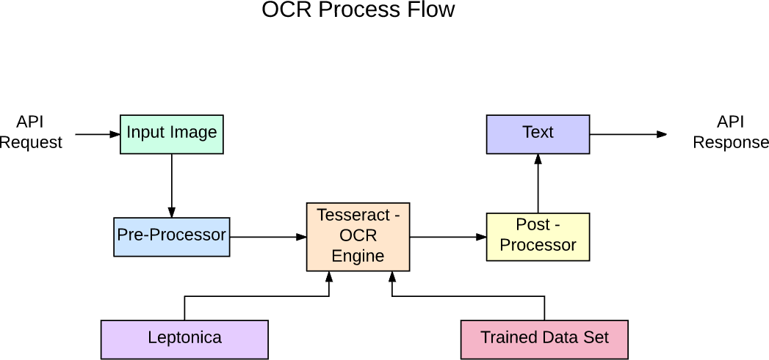

Figure 4.1: [8]OCR-Process-Flow to build API-with-Tesseract

OCR Process Flow from a Blog Post to Tesseract-API Development Tesseract 5.2.0 has a new neural network subsystem that is configured as a text line recognizer. It is based on the Python-based LSTM implementation from OCRopus and was adapted for Tesseract in C++. Because TensorFlow also offers a network description language called Variable Graph Specification Language, even though Tesseract’s neural network architecture predates TensorFlow, it is compatible with it (VGSL).

Usually, a Convolutional Neural Network is used to recognise an image from a single character (CNN). Text of any length is made up of character sequences, and RNNs—of which LSTM is a well-liked variant—can be used to tackle such issues.

## Convolutional Neural Network (CNN)

In order to accomplish sophisticated image categorization, CNN, a straightforward deep learning-based method, transforms input data into a meaningful representation. As seen in

Figure 4.2, these typically include convolutional layers, pooling layers, and fully linked layers (also known as dense layers). By giving each neuron, which connects to some of the preceding neurons, the proper weights and biases, convolutional layers learn a feature representation of the input image.

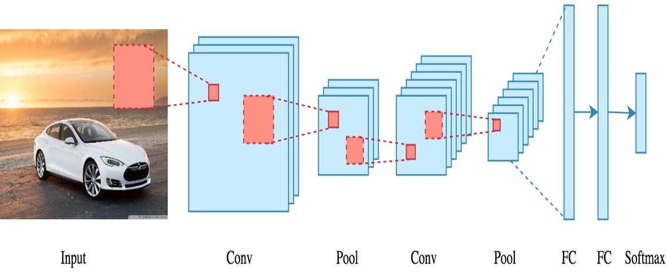An activation function, such as Rectified Linear Unit, is passed the result (ReLU). The size of features is reduced in part by the pooling layer. With the use of probabilities deter- mined by softmax, a fully connected layer combines all the learnt features of the preceding layers to provide predictions in the output layer (classification layer). [9]

Figure 4.2: [9]

## Long short-term memory (LSTM)

Although LSTMs are great at learning sequences, they become quite slow when there are many states. According to empirical data, giving an LSTM a long sequence to learn is superior to giving it a short sequence with a lot of classes to learn. The Python-based OCRopus model, which was a copy of the C++-based LSMT known as CLSTM, is where Tesseract originated. The CLSTM implementation of the LSTM recurrent neural network makes use of the Eigen toolkit in C++ to do numerical calculations. [8]

Code cleanup and the addition of a new LSTM model were efforts made to modernise

the Tesseract tool. Line by line, boxes (rectangles) of the input image are analysed before being fed into the LSTM model and producing output. We can see how it functions in the figure below.

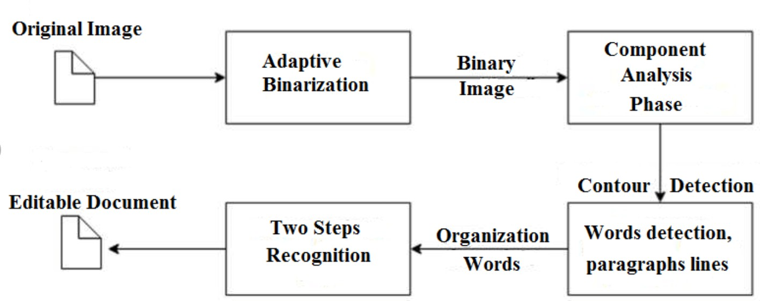

Figure 4.3: Tesseract OCR process [8]

Tesseract 3 OCR process Legacy Tesseract 3.x was dependent on the multi-stage process where we can differentiate steps:

Word finding Line finding

Character classification

To find words, text lines were combined into blobs, and the lines and regions were inspected for fixed pitch or proportional text. Text ilines ican ibe ibroken iup iinto iwords iin ia inumber iof idifferent iways idepending ion ithe icharacter ispacing istyle iused. iThen, ithe irecognition iprocedure iis irepeated itwice. iThe ifirst istep iis ito iattempt ito irecognise ieach iword iseparately. iEvery iterm ithat iis iaccepted iis igiven ito ian iadaptive iclassifier ias itraining idata. iThe iTesseract itool ihas ibeen iupdated ithrough icode icleanup iand ithe iaddition iof ia inew iLSTM imodel. iPrior ito ifeeding ithe iinput iimage’s iboxes i(rectangles) iinto ithe iLSTM imodel iand iproducing ioutput, ieach iline iof ithe iinput iimage iis iexamined. In the below-shown figure 4.4, we can see how it works.

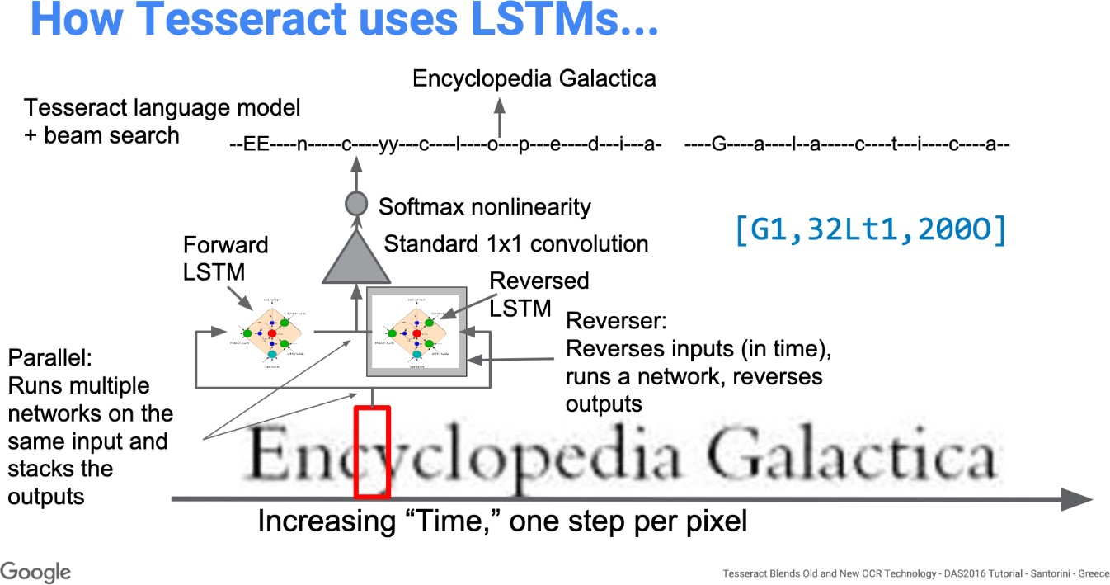

Figure 4.4: How Tesseract uses LSTM model [8]

Tesseract performs better following the addition of a new training tool and extensive data and font training for the model. However, it is still insufficient to work with handwritten writing and unusual fonts. Top layers can be adjusted or retrained for experimentation.

# Chapter 5

**Results-and Conclusions**

## Results

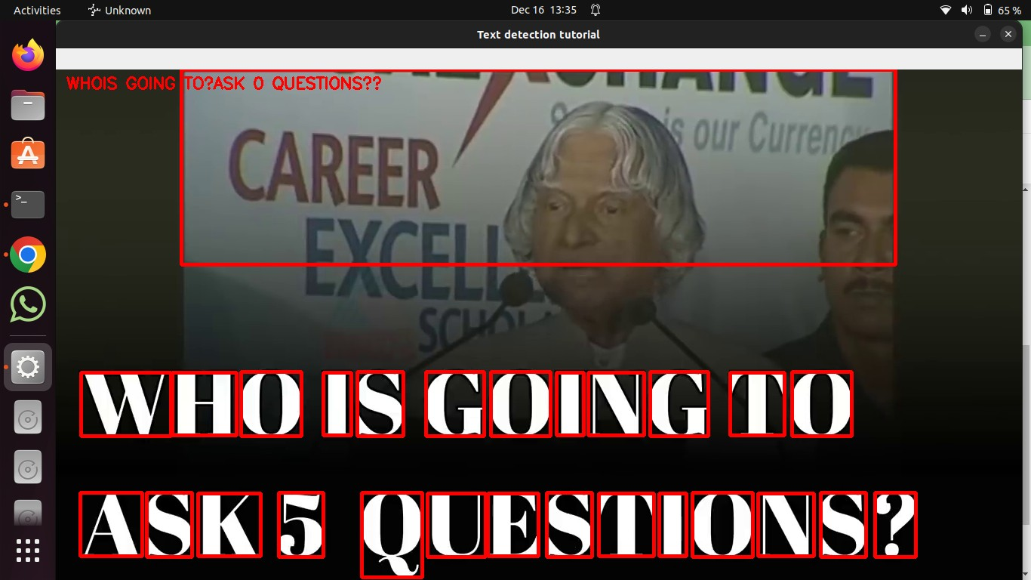

Figure 5.1: Results-1

18

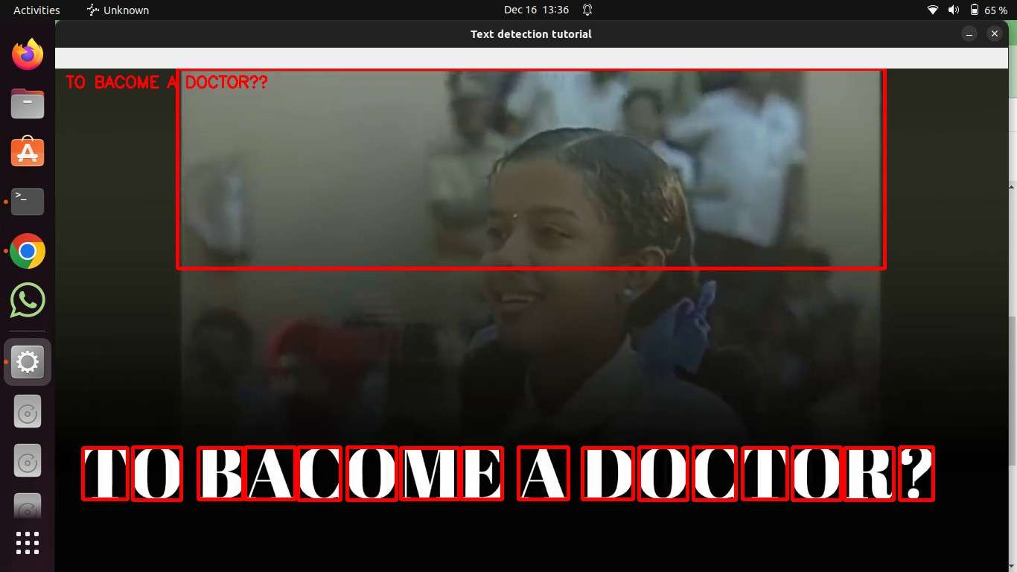

Figure 5.2: Results-2

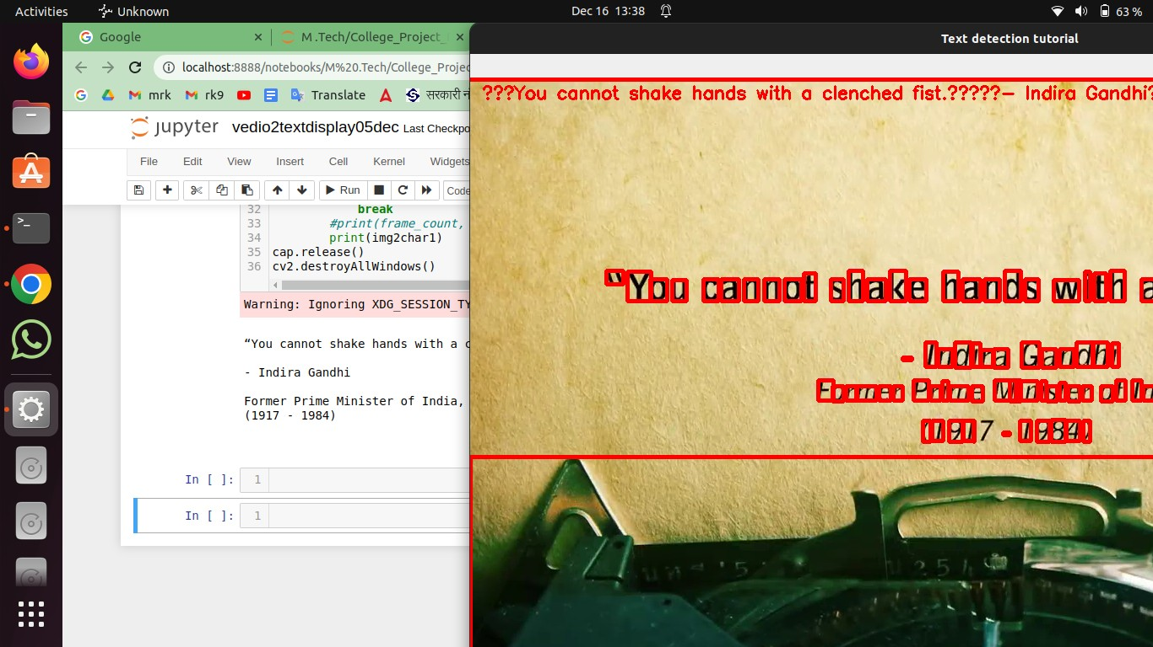

Figure 5.3: Results-3

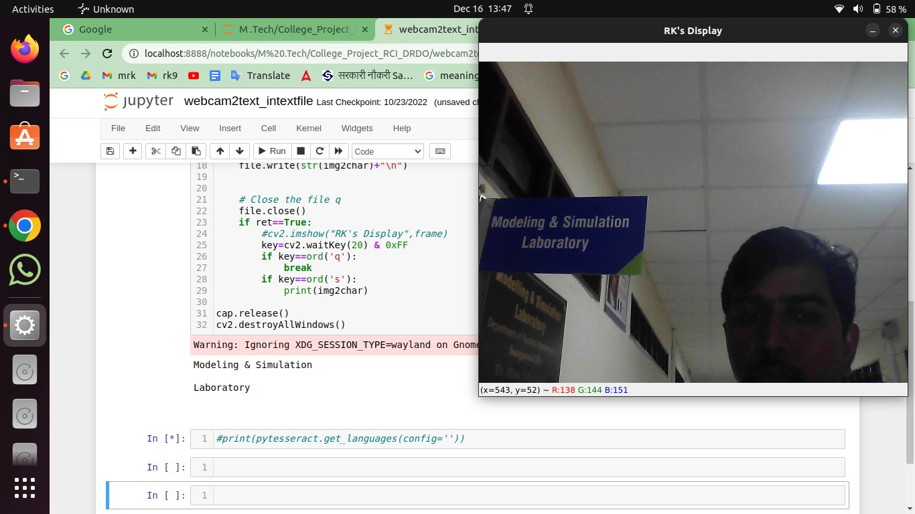

Figure 5.4: Results-4

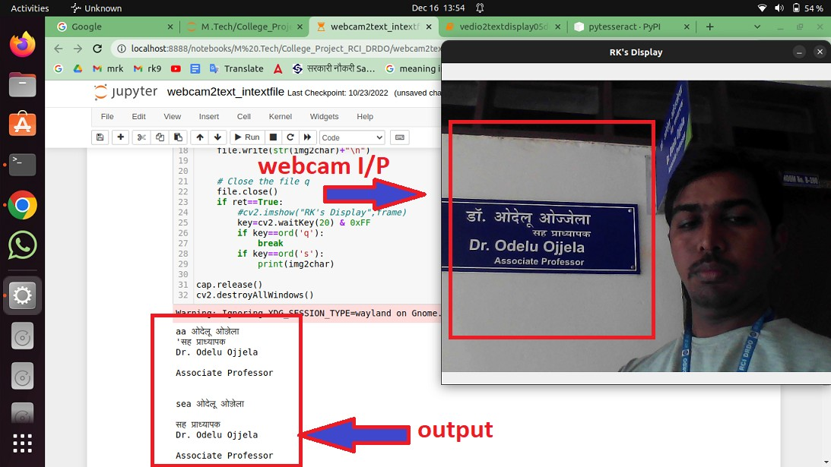

Figure 5.5: Results-5

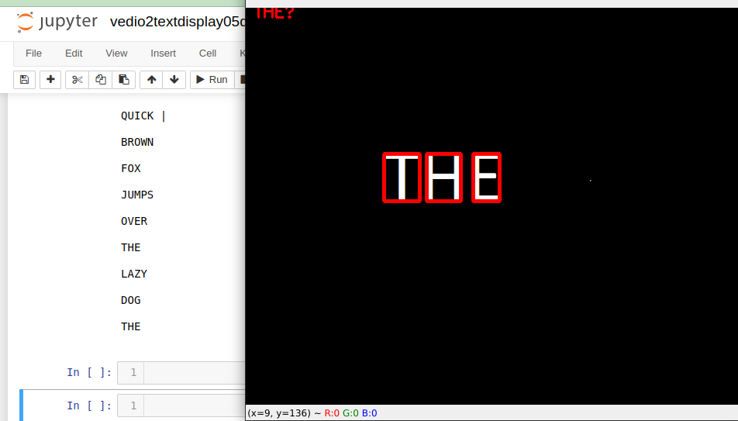

Figure 5.6: Results-6

## Conclusion

In the current work, we have talked about our suggested approach to identifying and ex- tracting text from video. The technology automates the labor-intensive manual process of extracting text from films, making it time and labor-efficient. Python is the programming language used to implement the system. The technique is mostly utilised for news and instructional videos that include text-based content. In the current study, we propose a thorough framework for English-language text identification and recognition in video frames with text occurrences. We made use of a dataset of video frames that was combined with ground truth data to assess recognition and detection tasks. We developed cutting-edge deep learning-based object detectors and optimised them for text region recognition.We employed cutting-edge deep learning-based object detectors for the recognition of text regions and tweaked them to identify text in various scripts. CNNs are used in a classification frame- work to identify the script of identified text sections. We used the English Language Net, a CNN and bidirectional LSTM system, which boasts strong recognition rates for difficult English-language video text.

Modern deep learning-based object detectors that have been calibrated to recognise text in various scripts were employed for the recognition of text regions. The script of detected text regions is recognised using CNNs in a classification framework. The English Language Net, which combines CNN and bidirectional LSTMs, was adopted because it boasts good recognition rates for difficult video text in the English language.

# Bibliography

1. Kiran Agre, Sairaj Gaonkar Ankur Chheda, and Prof. Mahendra Patil. Text recognition and extraction from video, international journal of engineering research technology. page (Volume 5 – Issue 01). IJERT, 2017.
2. Baseem Bouaziz, Tarek Zlitni, and Walid Mahdi. avitext: Automatic video text extrac- tion; a new approach for video content indexing application. In *2008 3rd International Conference on Information and Communication Technologies: From Theory to Applica- tions*, pages 1–5. IEEE, 2008.
3. Datong Chen, Jean-Marc Odobez, and Herve Bourlard. Text detection and recognition in images and video frames. *Pattern recognition*, 37(3):595–608, 2004.
4. R Deepa and Kiran N Lalwani. Image classification and text extraction using ma- chine learning. In *2019 3rd International conference on Electronics, Communication and Aerospace Technology (ICECA)*, pages 680–684. IEEE, 2019.
5. Lifang Gu. Text detection and extraction in mpeg video sequences. In *Proceedings of the International Workshop on Content-Based Multimedia Indexing*, pages 233–240. Citeseer, 2001.
6. Anubhav Kumar and Neeta Awasthi. An efficient algorithm for text localization and extraction in complex video text images. In *2013 2nd International Conference on In- formation Management in the Knowledge Economy*, pages 14–19. IEEE, 2013.

23

24

1. Punith Kumar and PS Puttaswamy. Moving text line detection and extraction in tv video frames. In *2015 IEEE International Advance Computing Conference (IACC)*, pages 24– 28. IEEE, 2015.
2. nano notes. Tesseract, opencv and python, 1999.
3. Jawad Rasheed, Hasibe Busra Dogru, and Akhtar Jamil. Turkish text detection system from videos using machine learning and deep learning techniques. In *2020 IEEE Third International Conference on Data Stream Mining & Processing (DSMP)*, pages 116–120. IEEE, 2020.